**Lesson 2 Demo 1**

**Setting up Ansible**

**Objective:** To install and set up Ansible

**Prerequisites:** You need to have Python 2.7 or higher, minimum 8 GB RAM, and SSH or SCP communicator.

**Tools required:** Ubuntu terminal

**Steps to be followed:**

1. Installing Ansible
2. Establishing connectivity between Ansible controller and the node machine

**Step 1: Installing Ansible**

1. Use the command below to check and install the required dependencies for the packages you need:

***sudo apt-get install -f***

1. Use the below command to update package repositories and get the latest package information

***sudo apt-get install software-properties-common***

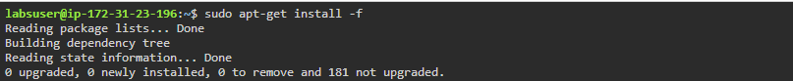

1. Run this command to update the list of available software again and install Ansible. It also pulls down **Ansible PPA's** signing key and **adds** it to the system

***sudo apt-add-repository ppa:ansible/ansible***

1. Use the below command to download package information from all configured sources

***sudo apt-get update***

1. Use the below command to install Ansible

***sudo apt-get install ansible***

1. Establish an SSH key pair in Linux system to have SSH connectivity with localhost using the following commands:

***ssh-keygen -t rsa***

***cat .ssh/id_rsa.pub >> .ssh/authorized_keys***

***ssh localhost -p 22***

1. Now, add the host localhost in the ansible host file /etc/ansible/hosts

***sudo vi /etc/ansible/hosts***

1. When the file opens, add the below two lines of the code at the end of the file:

***[webservers]***

***localhost:22***

**Step 2: Establishing connectivity between Ansible controller and node machine**

1. Execute the below command to validate host inventory file:

***ansible -m ping webservers***

